**Assignment -1**

Python Programming

|  |  |
| --- | --- |
| Assignment Date | 19 september 2022 |
| Student Name | ARUNACHALAM S |
| Student Roll Number | 111519104009 |
| Maximum Marks | 2 Marks |

**Question-1:**

## Split this string

|  |
| --- |
| **Solution:** |
|  | s **=** "Hi there Sam!" |
|  | print(s**.**split()) |
|  |  |
|  | #----------------------------------------# |
|  | #----------------------------------------# |
|  |  |
|  |  |
|  |  |
|  |  |

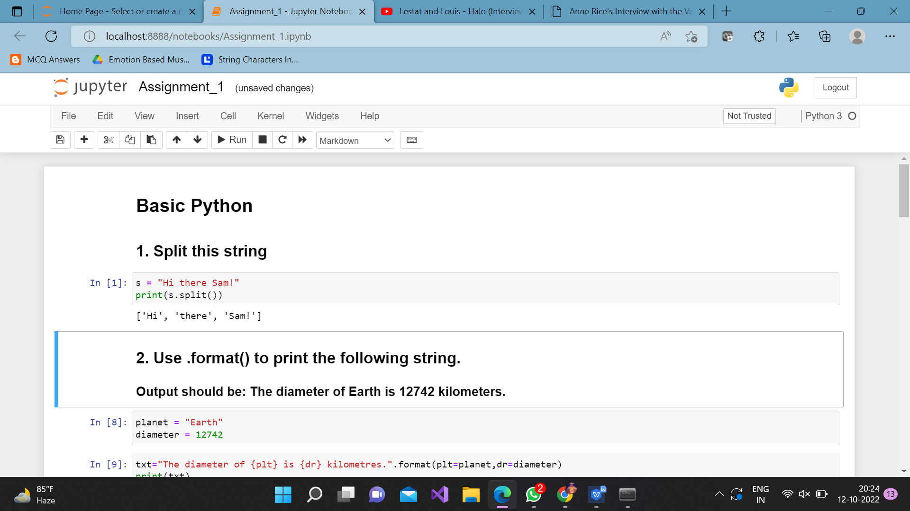

**Question-2:**

## Use .format() to print the following string.

## Output should be: The diameter of Earth is 12742 kilometers.

|  |
| --- |
| **Solution:** |
|  | planet **=** "Earth" |
|  | diameter **=** 12742 |
|  | txt**=**"The diameter of {plt} is {dr} kilometres."**.**format(plt**=**planet,dr**=**diameter) |
|  | print(txt) |
|  |  |
|  |  |
|  | #----------------------------------------# |
|  | #----------------------------------------# |

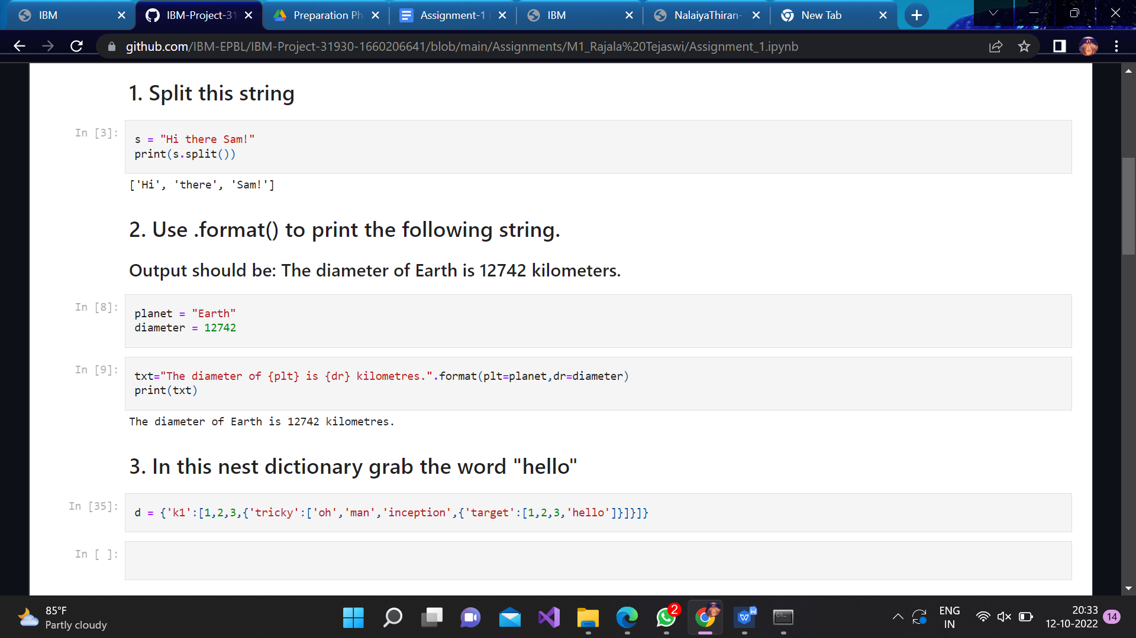

**Question 3:**

## In this nest dictionary grab the word "hello"

Solution:

|  |  |
| --- | --- |
|  | d **=** {'k1':[1,2,3,{'tricky':['oh','man','inception',{'target':[1,2,3,'hello']}]}]} |
|  |  |
|  |  |

**Question 4.1:**

## Create an array of 10 zeros?

Solution:

|  |  |
| --- | --- |
|  | **import** numpy **as** np |
|  | array**=**np**.**zeros(10) |
|  | print(array) |

Question4.2:

## Create an array of 10 fives?

Solution:

**import** numpy **as** np

array**=**np**.**ones(10)**\***5print(array)

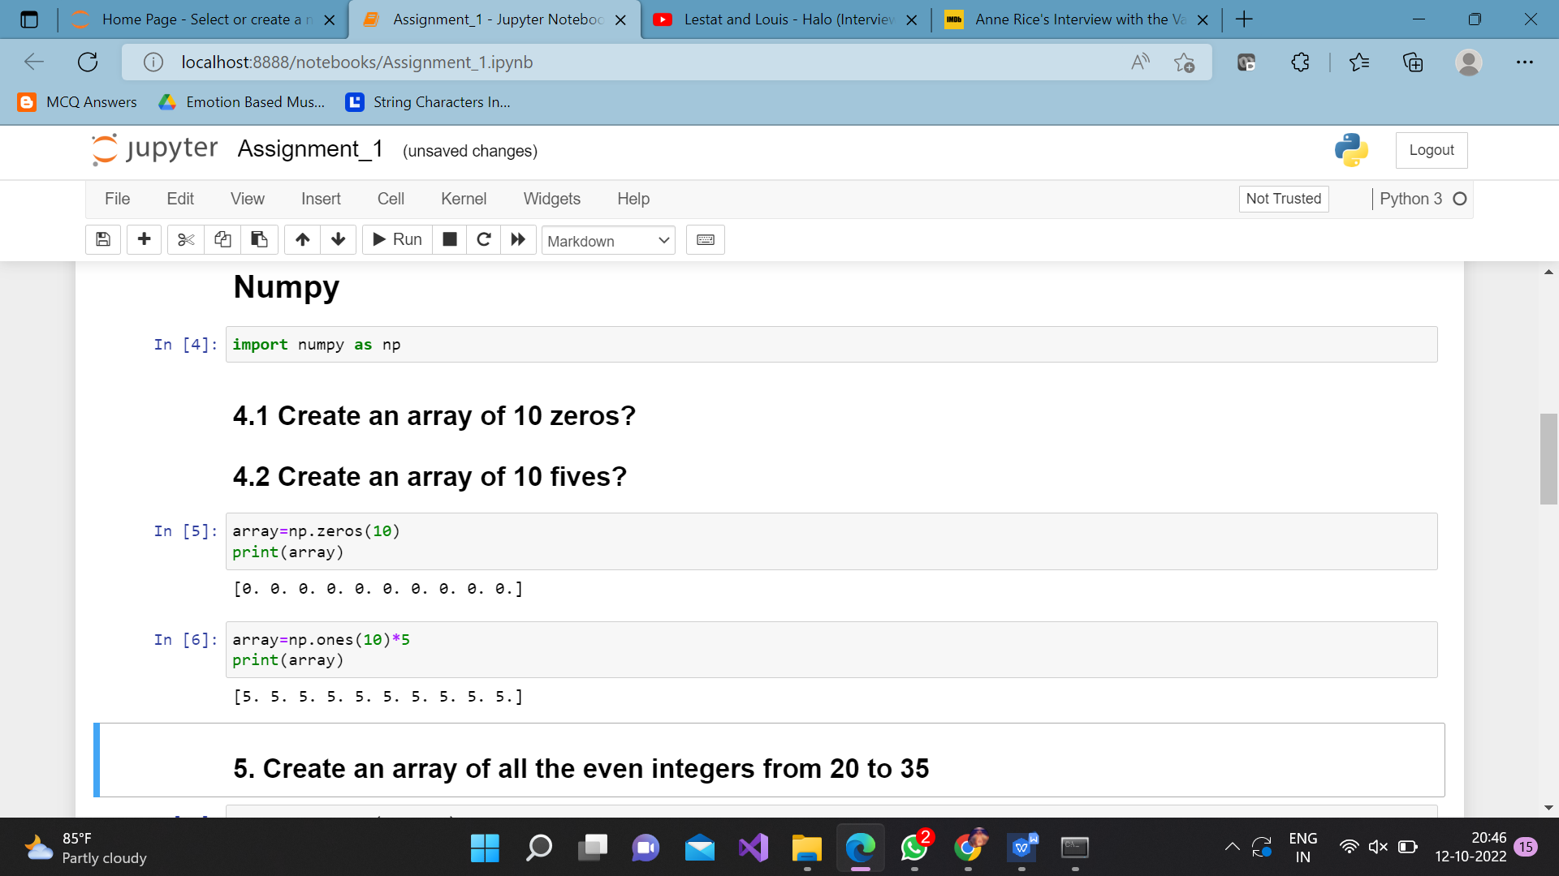

**Question 5:**

## Create an array of all the even integers from 20 to 35

Solution:

array**=**np**.**arange(20,35,2)

print(array)

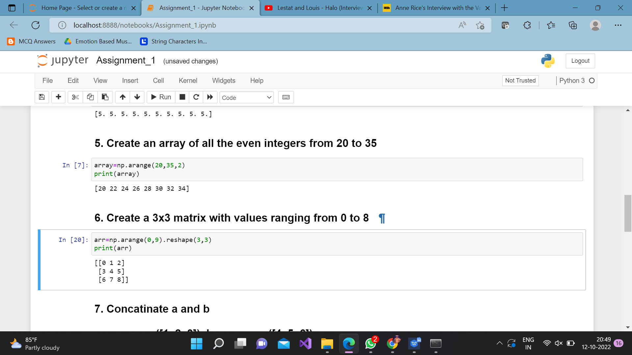

**Question 6:**

## Create a 3x3 matrix with values ranging from 0 to 8

Solution:

arr**=**np**.**arange(0,9)**.**reshape(3,3)

print(arr)

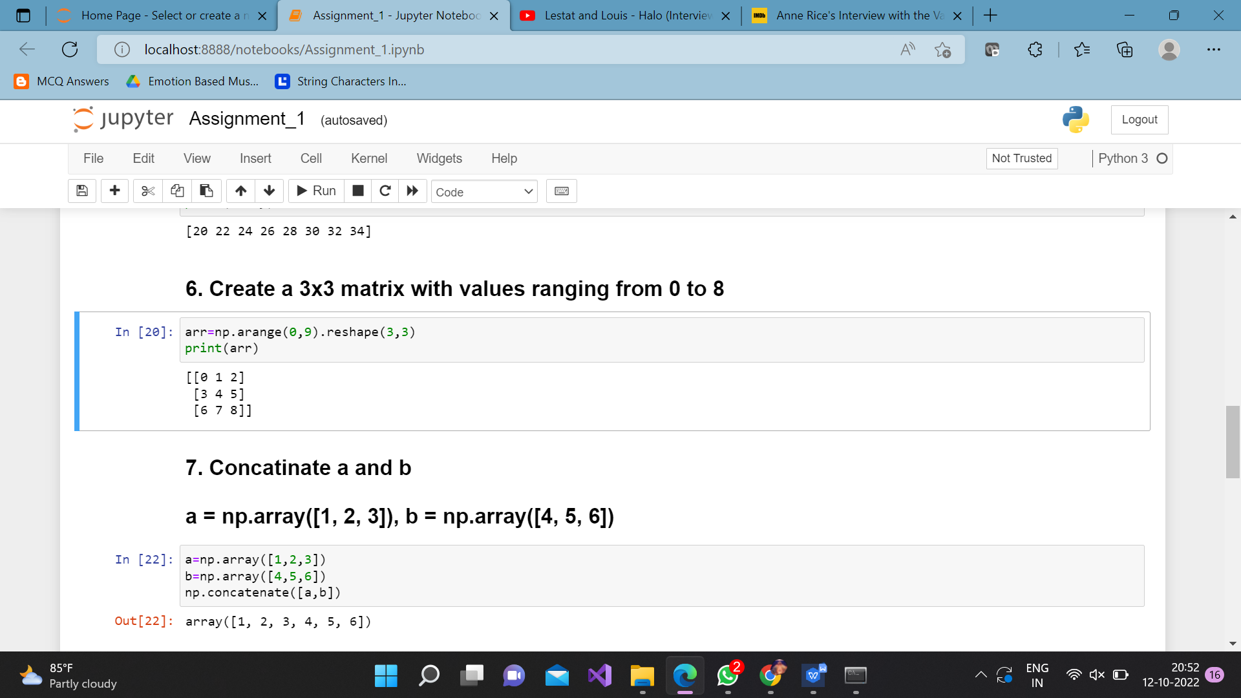

**Question 7:**

## Concatinate a and b

## a = np.array([1, 2, 3]), b = np.array([4, 5, 6])

Solution:

a**=**np**.**array([1,2,3])

b**=**np**.**array([4,5,6])

np**.**concatenate([a,b])

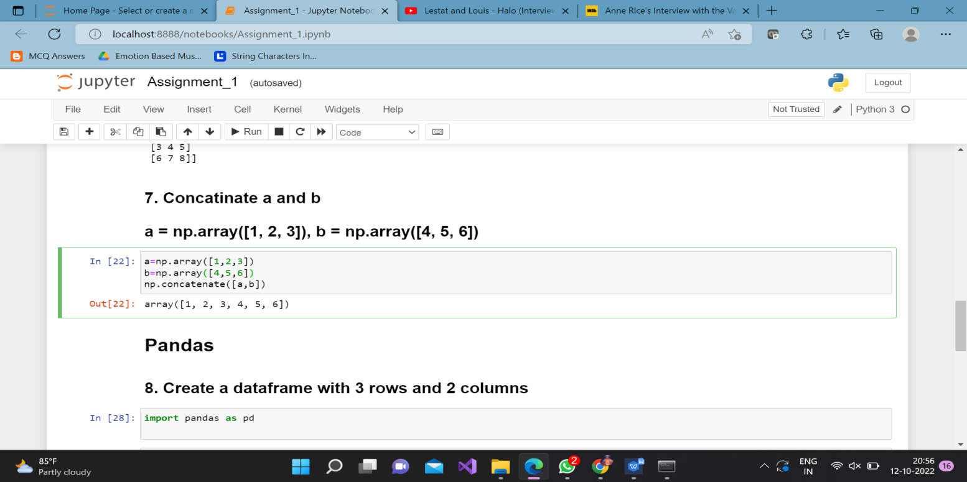

**Question 8:**

## Create a dataframe with 3 rows and 2 columns

Solution:

**import** pandas **as** pd

data**=**pd**.**DataFrame(index**=**np**.**arange(3), columns**=**np**.**arange(2))

print(data)

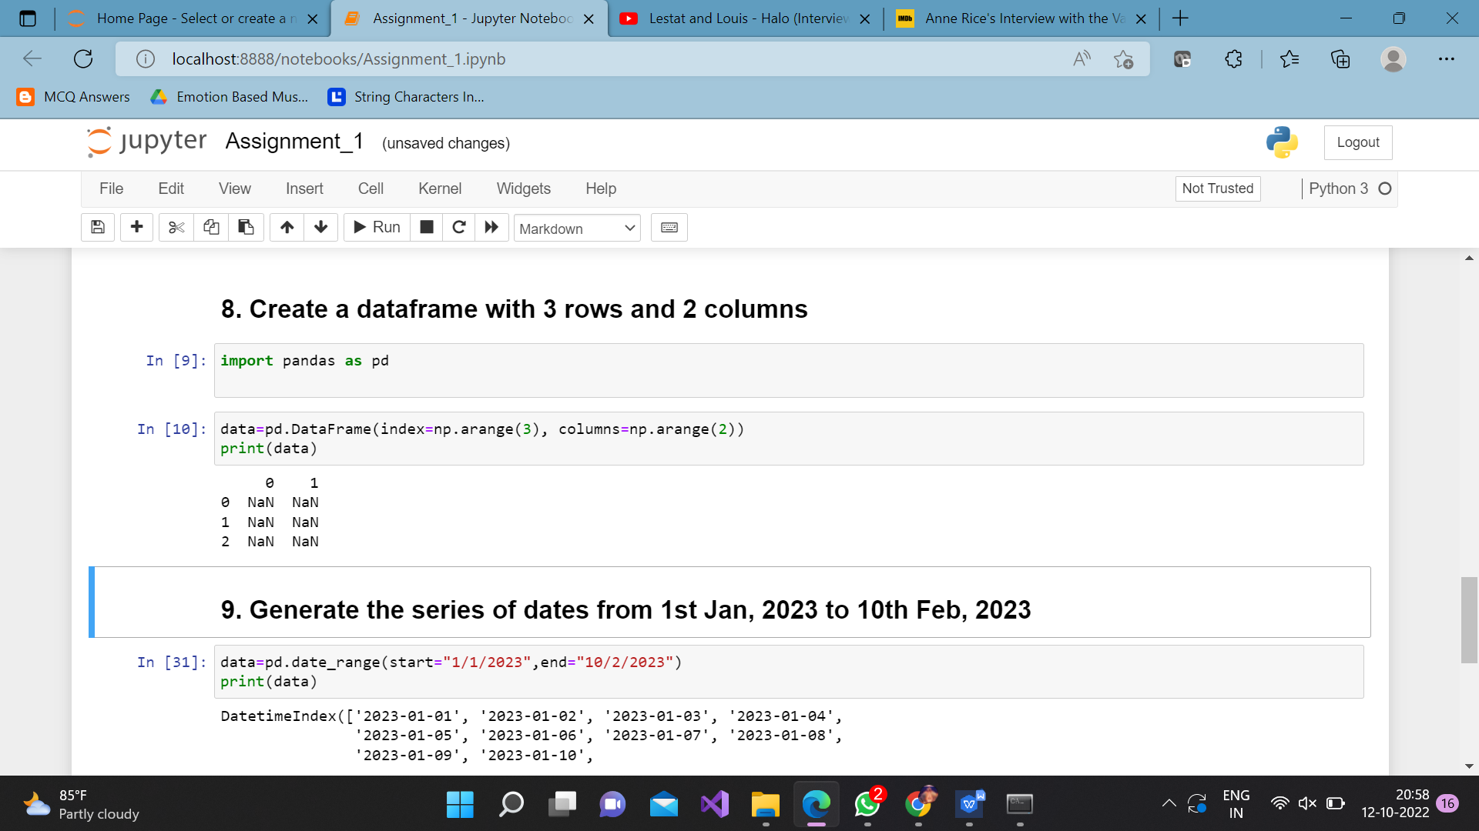

**Question 9:**

## Generate the series of dates from 1st Jan, 2023 to 10th Feb, 2023

Solution:

data**=**pd**.**date_range(start**=**"1/1/2023",end**=**"10/2/2023")

print(data)

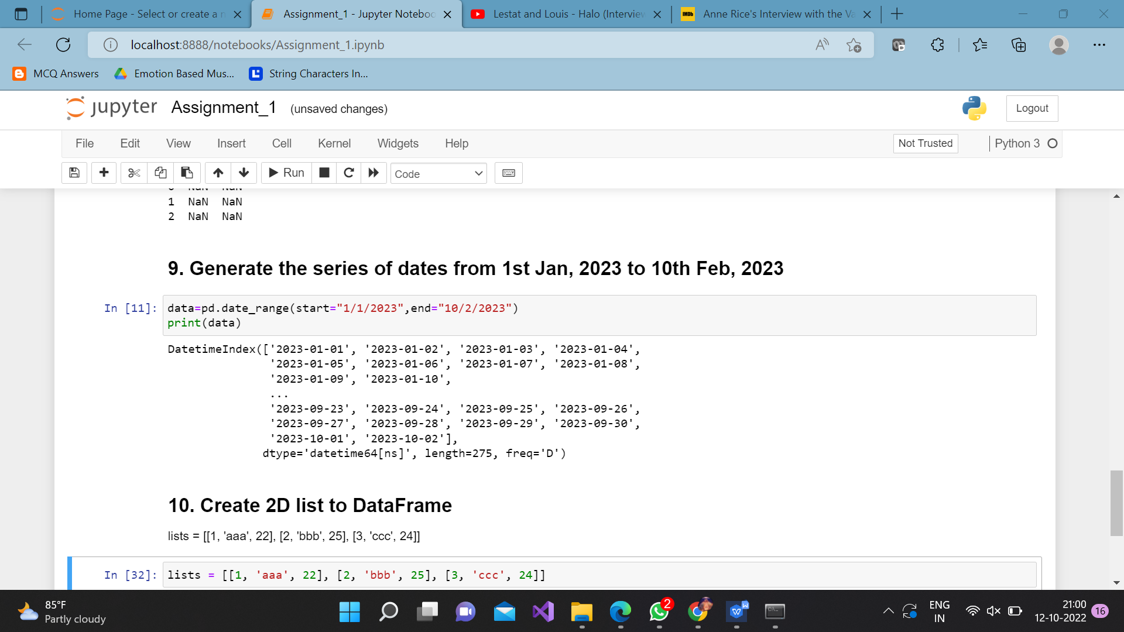

**Question 10:**

## Create 2D list to DataFrame

lists = [[1, 'aaa', 22], [2, 'bbb', 25], [3, 'ccc', 24]]

Solution:

lists **=** [[1, 'aaa', 22], [2, 'bbb', 25], [3, 'ccc', 24]]

data**=**pd**.**DataFrame(lists,columns**=**["s.no","pattern","number"])print(data)

